**Experiment - 2.4**

# Student Name: Vivek UID:

**Branch: BE-CSE Section/Group:**

# Semester: 3 Date of Performance:

**Subject Code: 21CSH214 Subject Name: DBMS**

**AIM:** Introduction and implementation of programs using Views.

# Objective: Implementation of programs using views.

**S/W Requirement:** Oracle Database 11g Express Edition

## VIEW

* A view is a virtual table.
* In SQL, a view is a virtual table based on the result-set of an SQL statement.
* A view contains rows and columns, just like a real table. The fields in a view are fields from one or more real tables in the database.
* You can add SQL functions, WHERE, and JOIN statements to a view and present the data as if the data were coming from one single table.

## Syntax

CREATE VIEW view_name AS SELECT column_name(s) FROM table_name

WHERE condition;

## Example 1:

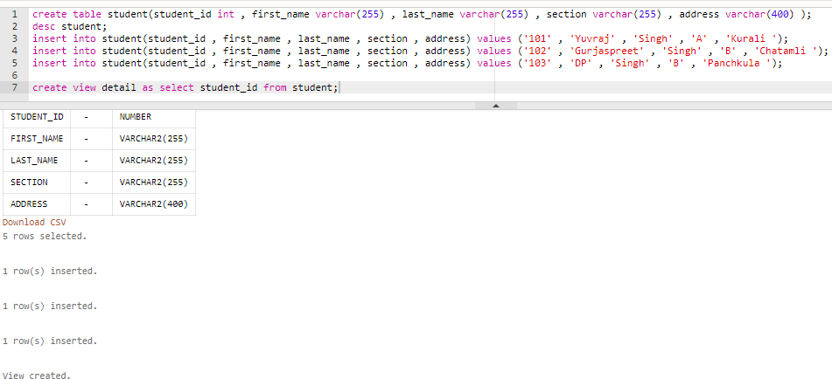

**Example 2:**

